**THE HARDWARE DESIGN DOCUMENT**

**Project:** Obstacle track-racer – A competitive robot design project

**Task:** Design and implement a working model out of EV3 Lego sets that would autonomously navigate to a racetrack on an island shown in the world map and complete as many laps as possible within the 5-minute time limit, eventually returning to its starting point.

**Document Version Number**: 3.0

**Date:** 28/03/2021

**Authors:** Dominic Chan,Yutong Wang

**Edit History:**

**Version 1.0:** Dominic Chan - 12/03/2021 (Completed the first/initial version of the hardware design document)

**Version 1.1:** Dominic Chan, Yutong Wang - 21/03/2021 (Added evolution of design section (section 2.5) and V1.0,1.1 in section 2.5)

**Version 1.2:** Dominic Chan, Yutong Wang - 21/03/2021 (Added V1.2 in section 2.5)

**Version 2.0:** Dominic Chan, Yutong Wang - 21/03/2021 (Added V1.3 in section 2.5 and completed the final design section)

**Version 3.0:** Dominic Chan, Yutong Wang - 28/03/2021 (Added V1.4, V1.5 in section 2.5, linked the hardware version with tests, )

# **1.0 TABLE OF CONTENTS**

**1.0 TABLE OF CONTENTS 1**

**2.0 INITIAL IDEAS AND DESIGNS 2**

**2.1 GENERAL DESIGN REQUIREMENTS AND CONSTRAINTS 2**

**2.2 INITIAL THOUGHTS AND IDEAS 2**

**2.3 PROPOSED DESIGNS 3**

**Design A 3**

**Design B 5**

**Design C 6**

**2.4 ANALYSIS 8**

**2.5 EVOLUTION OF DESIGN 8**

**Version 1.0 (V1.0) 8**

**Version 1.1 (V1.1) 9**

**Version 1.2 (V1.2) 10**

**Version 1.3 (V1.3) 11**

**Version 1.4 (V1.4) 12**

**Version 1.5 (V1.5) 14**

**3.0 FINAL DESIGN 16**

**4.0 GLOSSARY OF TERMS 16**

# 

# **2.0 INITIAL IDEAS AND DESIGNS**

## **2.1 GENERAL DESIGN REQUIREMENTS AND CONSTRAINTS**

When coming up with ideas for the hardware design of our solution, we have to consider the clients needs and requirements for the robot, as well as constraints to our design. (REFER TO REQUIREMENTS DOCUMENT)

To summarise, based on our playing field, the width of our robot must be smaller than 1 foot (30cm) to fit on the bridge, and our design must be built purely from the components of three Lego Mindstorms EV3 Kits, where it can implement at most four sensors and four motors. The following are components that we need:

* Ultrasonic Sensor
* Color Sensor
* Motors
* Wheels
* EV3 Brick

## **2.2 INITIAL THOUGHTS AND IDEAS**

When initially brainstorming and coming up with ideas on how our design should be, we made use of our experiences with previous laboratories and came up with a set of performance goals which could help maximise the effectiveness of our hardware design.

Firstly, for the size of the robot, we wanted the robot to be as compact as possible, so the turning radius would be smaller. This would help the robot with turning in tight spaces without colliding, allowing the robot to be more mobile and precise. Furthermore, since the whole competition is based on the speed in which the robots complete their tasks, it is important that our robot runs as fast as possible. Thus, we have to consider the center of gravity of our robot to ensure that our robot is stable. Lastly, it would also be beneficial for our robot to be as accurate as possible during the process of navigation, so that the robot would not have to spend too much time localising to correct errors. Through the careful consideration of the above concepts, we devised and sketched out a tentative design of what we expect our robot to look like, as well as the features it should have. This is shown in Figure 1 below.

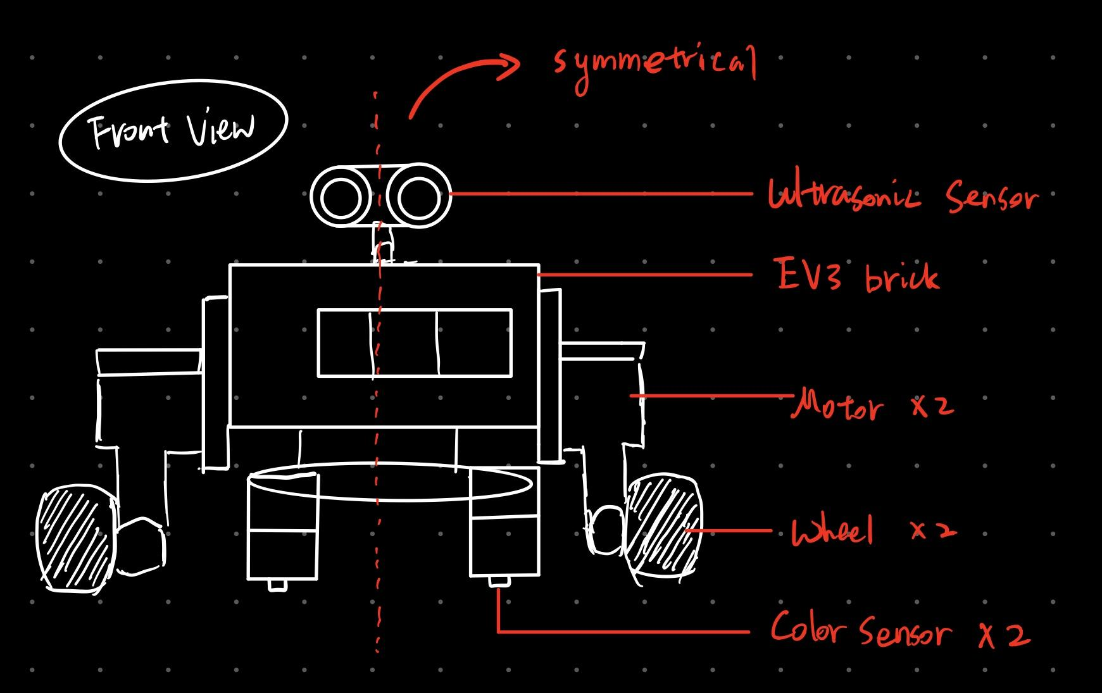

**Figure 1: Initial design idea**

## **2.3 PROPOSED DESIGNS**

Through each other’s experiences with different aspects of the designs that worked well in previous laboratories, we were able to narrow it down to three new designs that would fit the purpose and requirements of this project.

### **Design A**

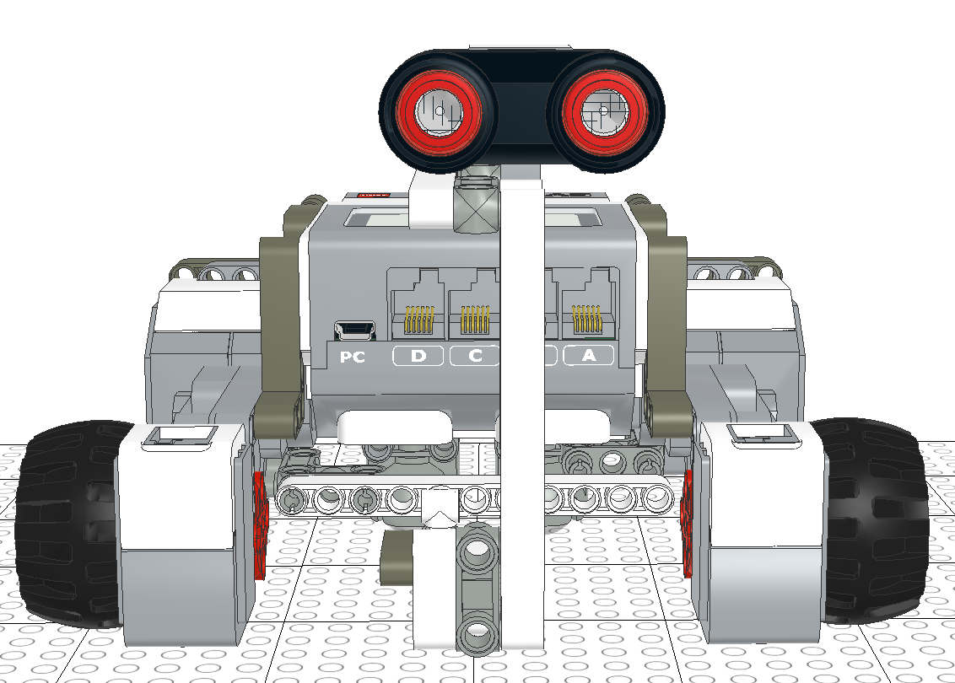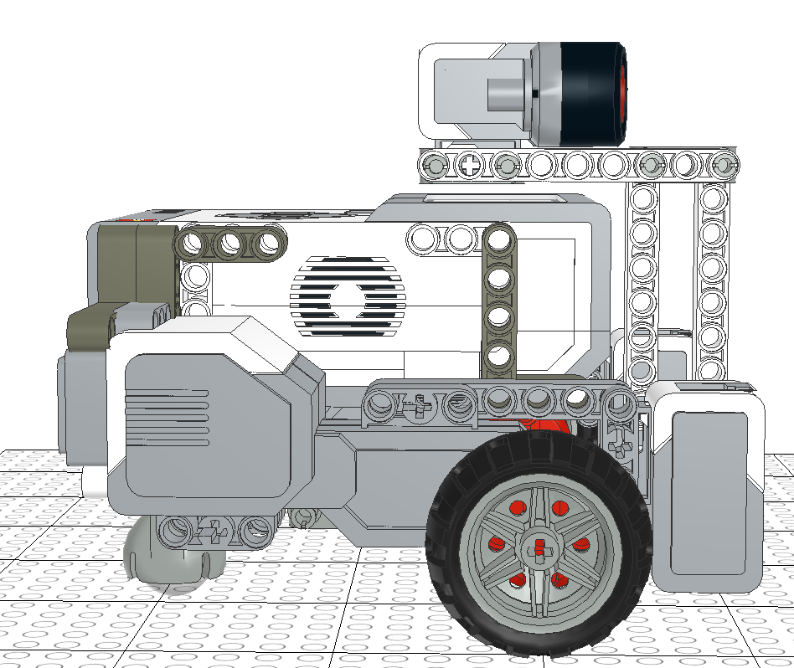

**Figure 2: Front view of Design A. Figure 3: Side view of Design A.**

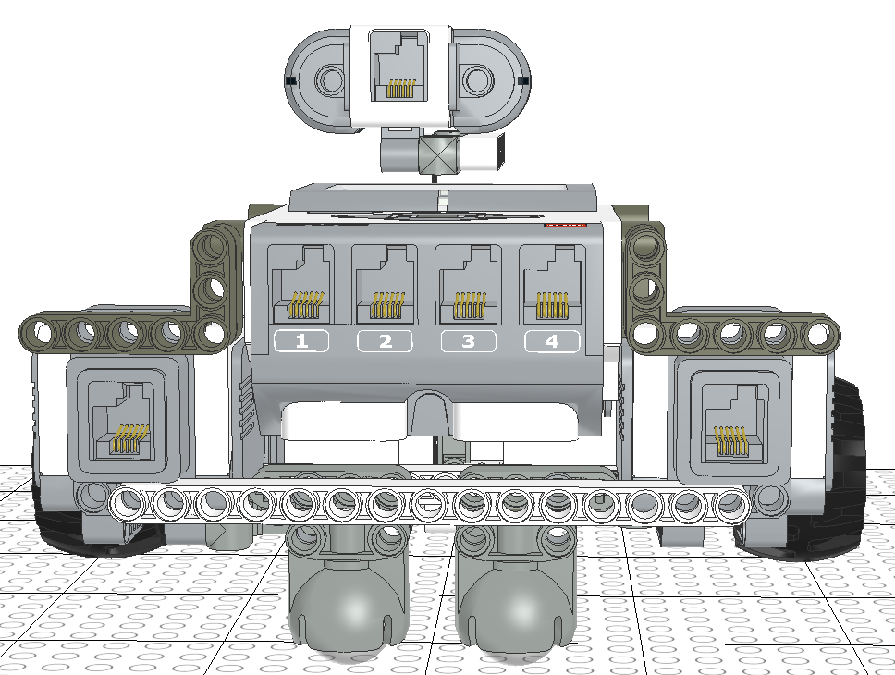

**Figure 4: Back View of Design A**

For this design, our ultrasonic sensor was placed on top of the EV3 brick at a fixed position (Figure 2), two color sensors were in parallel quite far apart from each other at the front of the robot (Figure 2), and two ball casters are implemented at the back of the robot as shown in figure 4.

Note that both color sensors aren’t placed too close to the ground, as we noticed from previous labs that if this is the case, the sensor may sometimes fail to work. Also, we realised that by using 2 ball casters instead of 1 will also help increase the robot’s stability.

Advantages:

* The two color sensors are placed relatively far from each other, and aren’t too close to the ground, so it can consistently detect lines on both sides of the robot.
* The design is relatively compact, as all components are placed relatively close to the EV3 brick. Makes the robot’s turning radius smaller.
* The use of two ball casters will increase the stability of the robot and decrease errors.
* The design is also symmetrical, as everything on one side will be on the other too. Therefore, this causes the center of gravity to be at the center of the robot, which also makes it more stable.

Disadvantages:

* The Ultrasonic sensor is at a fixed position and angle, so if the obstacles are on the side or at an angle to the sensor, there is a chance the sensor will fail to detect it.
* Since the center of rotation (the midpoint between two wheels) is not the same point as the center of the EV3 brick, and the position of the robot is defined as the position of the center of EV3 brick, there will be a small deviation in the robots actual position and the odometry’s calculated position when the robot turns.

### **Design B**

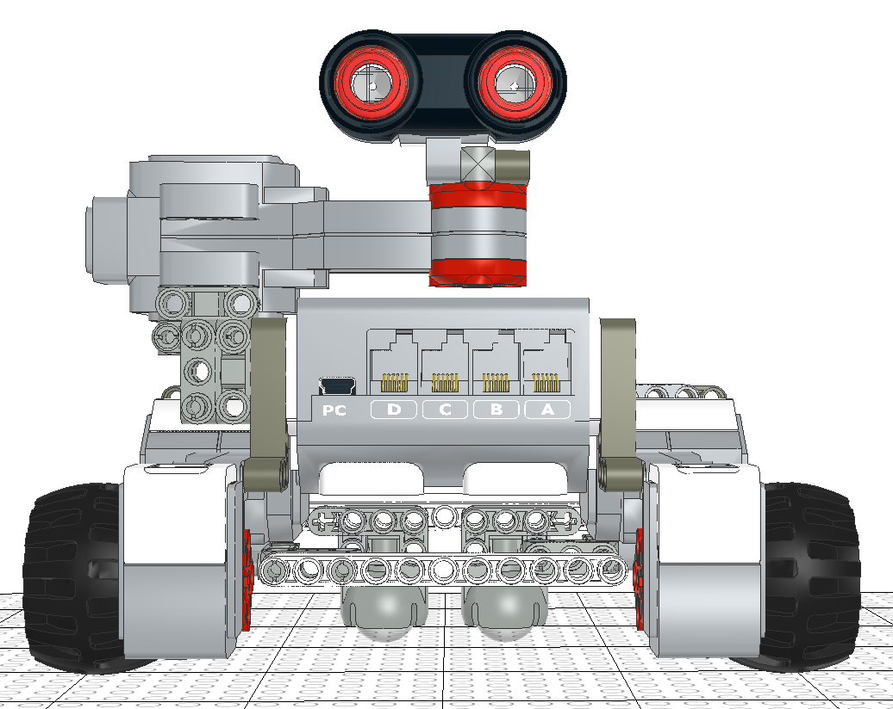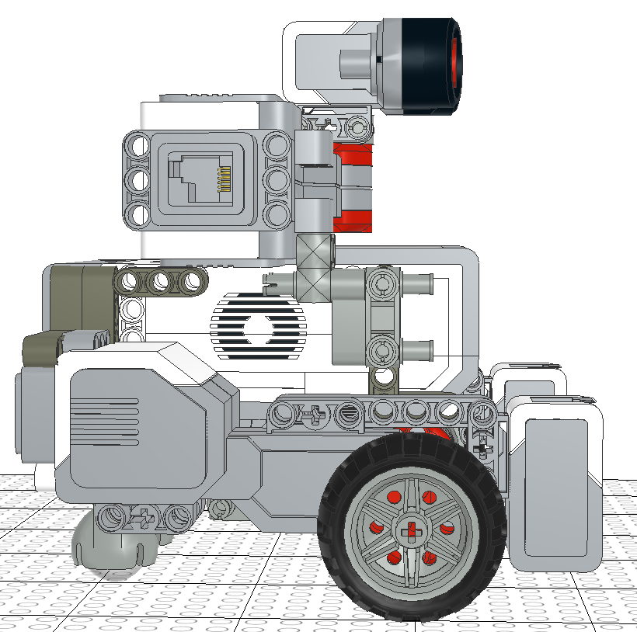

**Figure 5: Front view of Design B. Figure 6: Side view of Design B.**

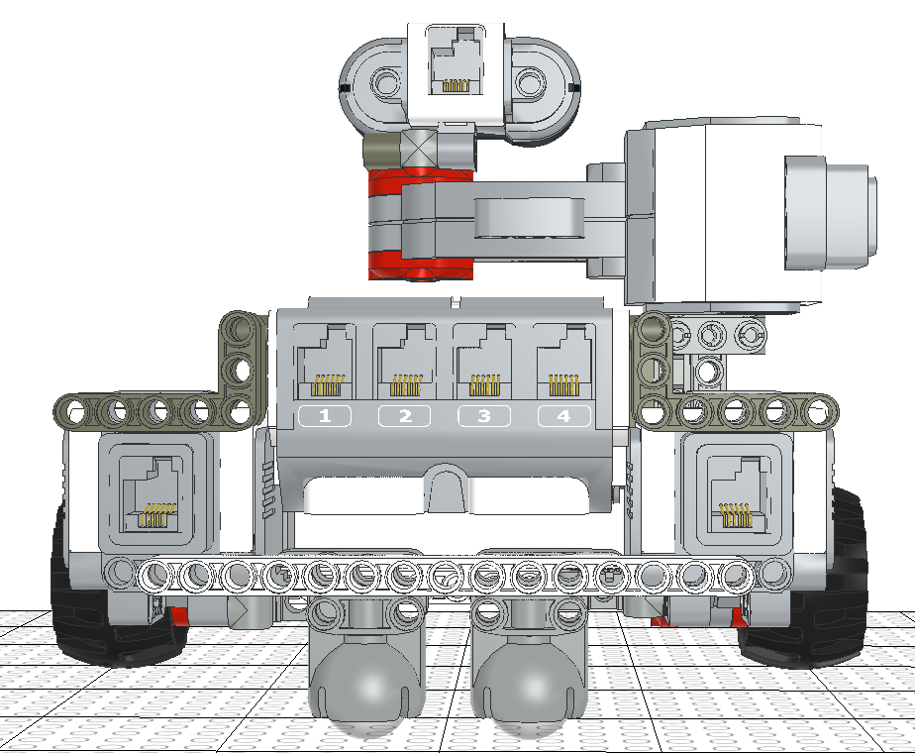

**Figure 7: Back view of Design B.**

For this design, the color sensors and ball casters remain in the same position as in design A. The big difference however, is with the ultrasonic sensor, where it is placed above the robot, attached to a motor that extends upwards from the side.

Advantages:

* The positions of the two color sensors are maintained from Design A, so the sensors can detect the color accurately.
* The two ball casters remain in the same position as well, so the robot will be relatively stable.
* The ultrasonic sensor in this design is controlled by a motor, allowing the sensor to turn by itself. Thus, it negates the need for the robot to turn when localising, which reduces the errors incurred due to positioning inaccuracies when turning. It can also detect obstacles in all directions, helping with obstacle avoidance.
* Although the robot is taller than in previous designs, the robot is still relatively compact, as the length and width of the robot remains the same.

Disadvantages:

* This design increases the complexity of software design. Since an extra motor is added in this design, more code must be implemented into the software design to handle the motor.
* With more components being located on the right side of the robot, it causes the right side to be heavier than the left side, which reduces the robot’s stability as well as mobility.
* When navigating and avoiding obstacles, the spinning of the sensor may still cause some obstacles to be unable to be identified. An example could be when the sensor is facing backwards, and there is an obstacle in front of the sensor. Since the sensor is spinning while the robot is moving, it may not be able to spin around in time for it to detect the obstacle at the front, leading to a collision.

### **Design C**

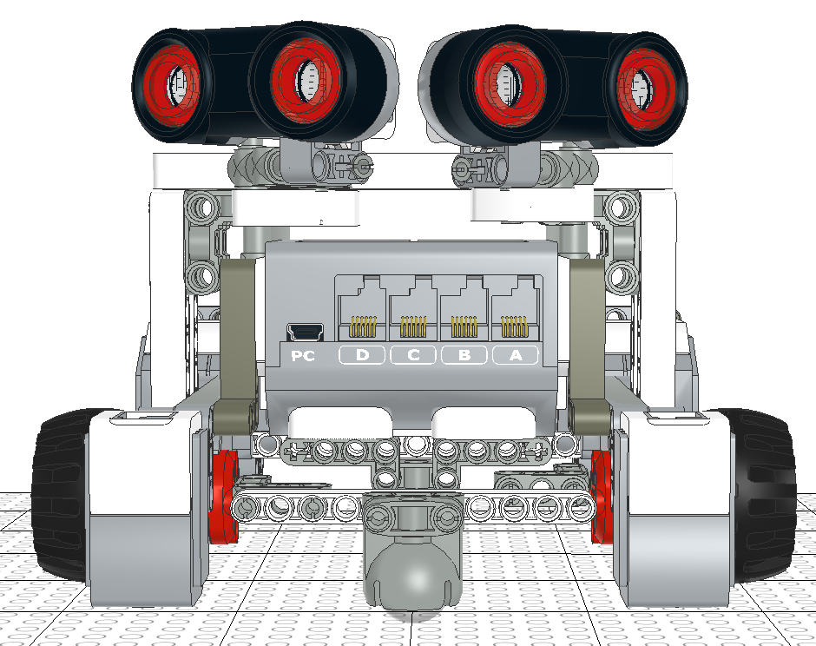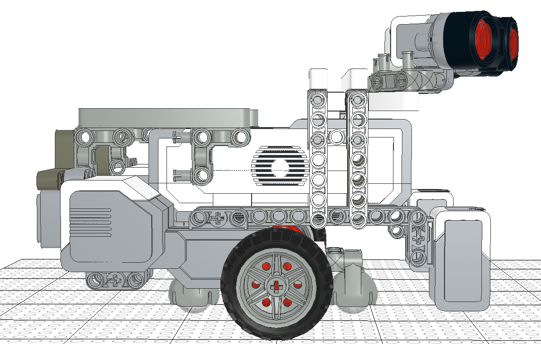

**Figure 8: Front view of Design C. Figure 9: Side view of Design C.**

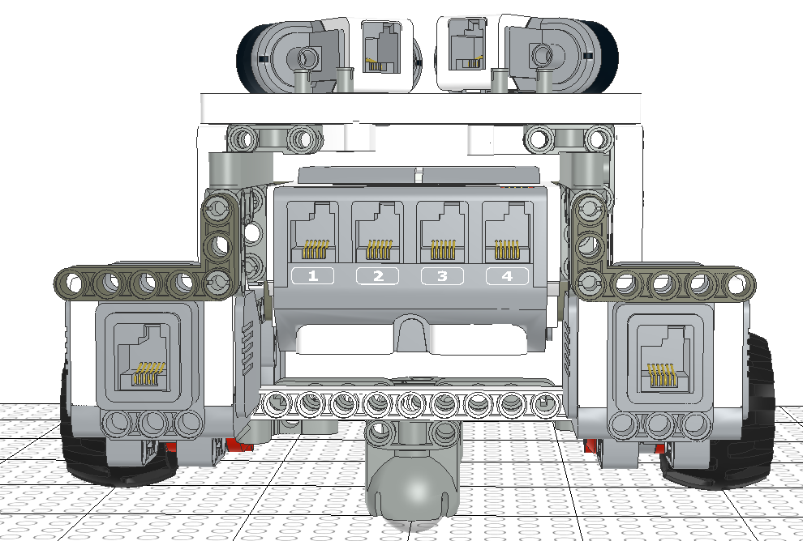

**Figure 10: Back view of Design C.**

For design C, the two color sensors are located in the same place as that in design A. However, two ultrasonic sensors are implemented here, and are placed on top of the robot at angles of 30 degrees and -30 degrees (Figure 8). A ball caster is placed at the front and back of the robot (Figure 8,9,10), and the two motors and wheels are moved backwards relative to design A (Figure 9).

Advantages:

* By making use of two ultrasonic sensors instead of one, and placing them at an angle allow the robot to detect objects both in front of and to the side of the robot (at an angle to the robot).
* By moving the two motors and two wheels backwards, the center of rotation (midpoint between two wheels) would be the same point as the center of the robot. This allows for the position of the robot to remain constant while turning, reducing errors associated with differences in the robot’s actual position and the odometer’s calculated position.
* An extra ball caster is added at the front of the robot in order to keep the robot balance.
* The robot is symmetrical, therefore the center of gravity is in the middle of the robot.

Disadvantages:

* The robot will not be as compact as previous designs as the robot is longer. This increases the turning radius (space needed for the robot to turn), and so reduces its mobility.
* The implementation of an extra Ultrasonic sensor will increase the complexity of the software design, as the two sensors will likely have different readings for obstacles located around them, so it will be more difficult to handle these differences to avoid the obstacle.

## **2.4 ANALYSIS**

For design A, although the robot is compact, stable and mobile, which would improve the navigational accuracy of our robot, since the center of rotation is different to the center position defined by the odometer, this error will counteract the improvement in navigational accuracy of the robot, making these modifications relatively negligible in the grand scheme of things. On the other hand, since the fact that the ultrasonic sensor is placed at a fixed position facing forward, this causes the detection of obstacles located at angles to be slightly more inconsistent. Considering that the aspect of obstacle avoidance is vital to the completion of the competition, this is a downside to this design.

As for design B, it can be evaluated that the stability and mobility of this design is not as good as that in design A, due to the overload of hardware components on the right side of the robot. Also, the reduction in turning errors due to the implementation of the ultrasonic sensor for the localisation process is not too significant, as the reduced errors from the robots reduced stability will be of similar magnitude. In addition, since the rotating ultrasonic sensor will still be unable to detect all obstacles at a certain point in time, this is quite a big flaw considering that obstacle avoidance plays an important role in the completion of the competition.

Lastly, although the stability and mobility of design C is not as good as that for design A, it is greater than that of design B. However, since the center of rotation for this design is the same as the center point of the robot, this actually reduces odometry errors, causing the positioning and navigation of the robot to be more accurate in general. Furthermore, with the implementation of two ultrasonic sensors, located at 30 degrees and -30 degrees respectively, this allows for obstacles around the robot to be detected, allowing for the obstacle avoidance aspect of the robot to work more smoothly.

## **2.5 EVOLUTION OF DESIGN**

### **Version 1.0 (V1.0)**

After several tests and careful consideration of the different designs above, we decided to use design A, as this design finds the perfect balance between practicality, accuracy and ease of software implementation. The reason we didn’t use Design B was due to its inability to detect all obstacles at a certain point in time and avoid obstacles consistently. Whereas for design C, although the use of two ultrasonic sensors would perfect the obstacle avoidance aspect of the robot, our tests have shown that the obstacle avoidance aspect for design A is consistent enough for it to function smoothly for most cases. Thus, since design C would require a much more complex software implementation, our team agreed that it would be more efficient for us to implement design A instead of design C given the time-budget restraints for this project. Therefore, design A was chosen to be the first version (V1.0) of our hardware design. The chosen design is shown in figures 2, 3 and 4 of Section 2.3.

### **Version 1.1 (V1.1)**

However, when we started implementing the hardware to start our project, we ran into a few problems that we hadn't initially expected. The first problem was that the robot is tilted forward in general, as shown in Figure 11. Although this problem doesn’t interfere with the general navigation or obstacle avoidance functionality of the robot, it causes stability issues especially when navigating up and down the bridge leading from the starting island to the main island. Therefore, to solve this problem, since the weight of the components in front being heavier causes a weight imbalance for the robot, we slightly raised the height in which the two ball casters were placed (Figure 12), which balanced the weight of the front and the back of the robot, fixing the issue. This new and improved hardware design is Version 1.1 (V1.1). Note that since the only thing that's changed from V1.0 was the position of the ball casters at the back of the robot, so the front and side views of V1.1 is the same as that for V1.0 (Figure 2 & 3 in section 2.3).

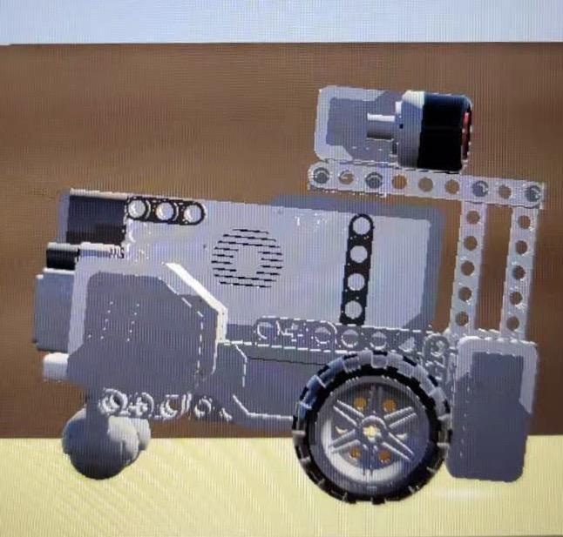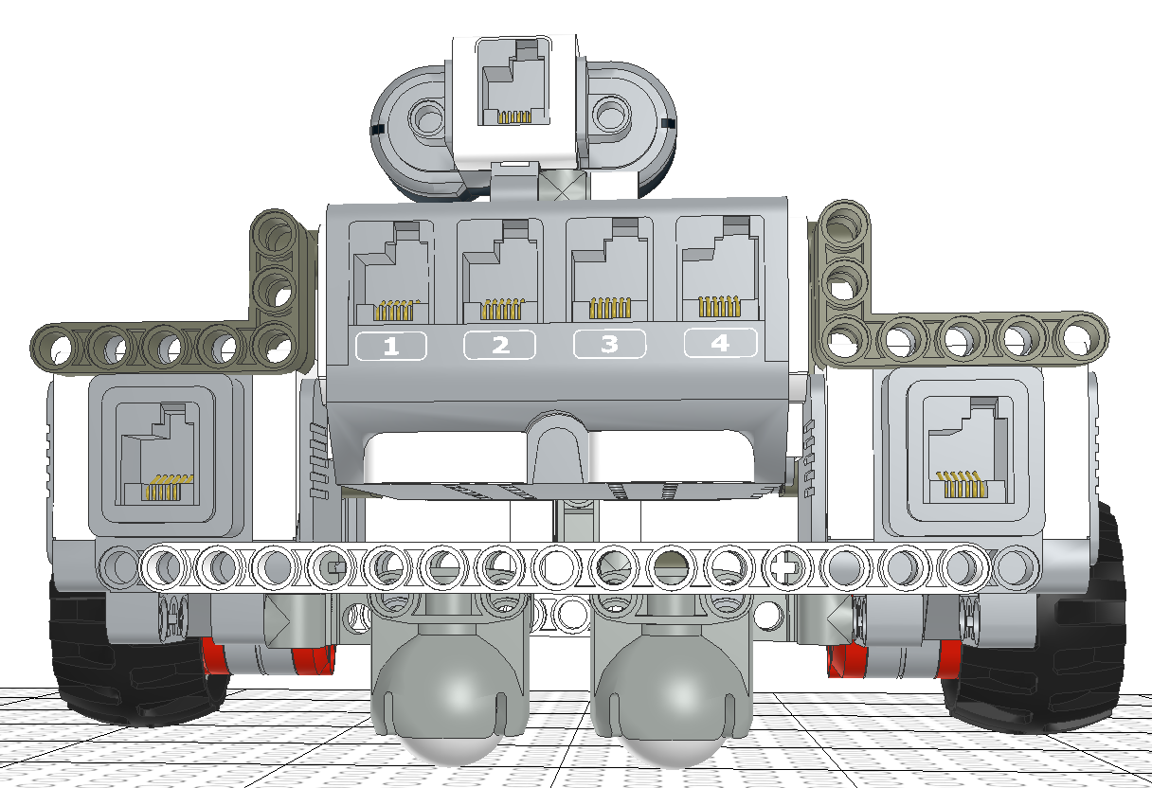

**Figure 11: Robot leaning forward (V1.0) Figure 12: Back View of Version 1.1 (V1.1)**

To ensure that our new hardware design was capable of completing required tasks, we conducted tests on V1.1. A summary of the tests can be seen in Table 1 below:

|  |  |  |  |  |
| --- | --- | --- | --- | --- |
| Hardware Design Version: | Name of Test: | Pass/Fail | Type of problem | Link to Testing Document: |
| V1.1 | Go Over Overpass | Fail | Hardware | Test 1 in [Go Over Overpass testing document](https://docs.google.com/document/d/1ntKasrLQ6Y_eLAAidyk6L0FvTIGCx-GSZtqNbJkSr4E/edit) |

Table 1: Testing of V1.1

### **Version 1.2 (V1.2)**

As shown in Table 1, when attempting to go over the bridge, there was a problem with hardware design V1.1 (Refer to Test 1 in the [Go Over Overpass testing document](https://docs.google.com/document/d/1ntKasrLQ6Y_eLAAidyk6L0FvTIGCx-GSZtqNbJkSr4E/edit)). Here, we found that the design V1.1 of the robot was unable to move up the connecting bridge because the height of both the two color sensors and ultrasonic sensor support was too low, causing the front-end of the robot to be stuck scratching the slope of the bridge (Figure 13).

Once again, we solved this issue by increasing the height of both color sensors as well as the ultrasonic sensor support, as this enables the front-end of the robot to not make contact with the slope. These adjustments in our design leads us to Version 1.2 of our Hardware design, which can be seen in Figures 14, 15 and 16.

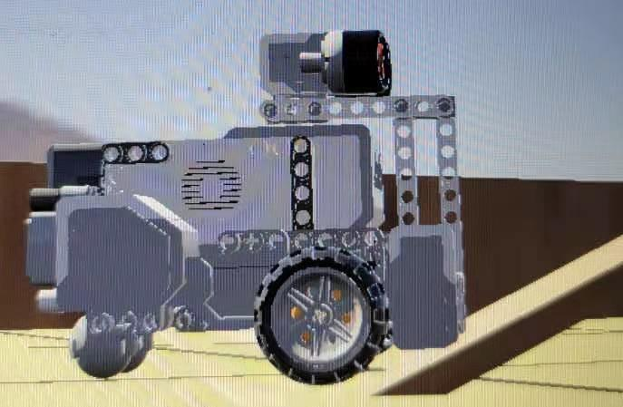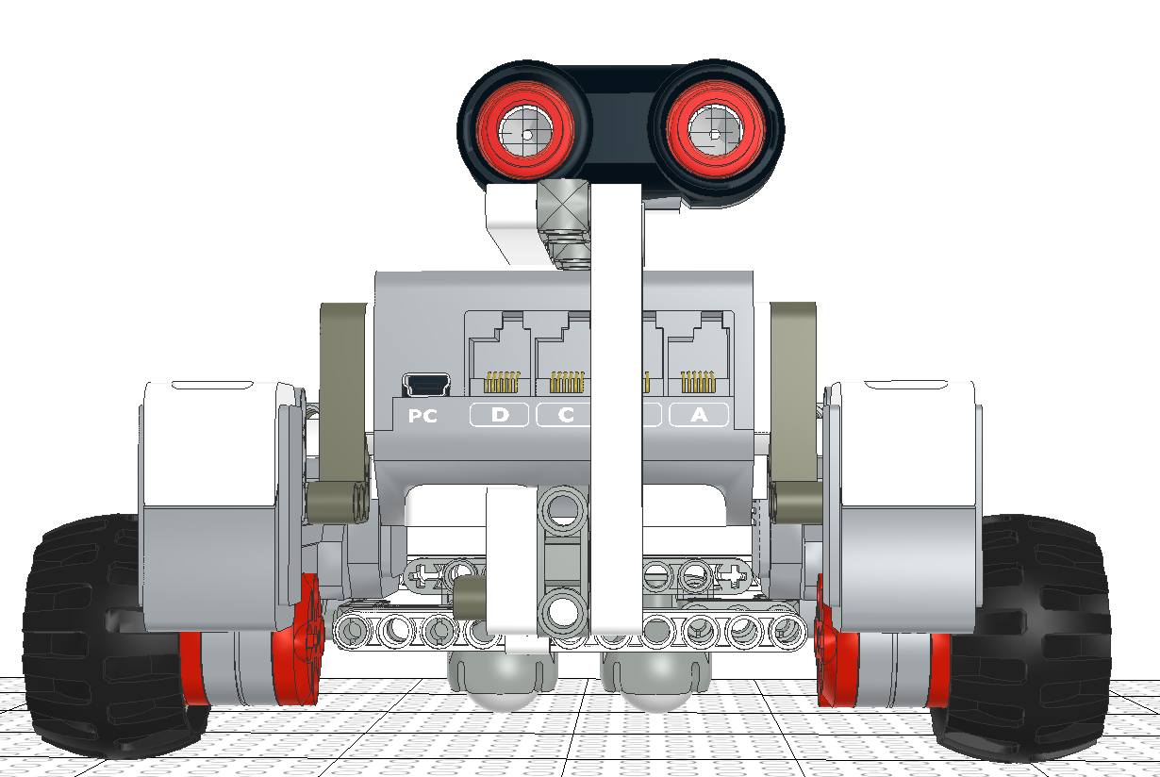

**Figure 13: Unable to climb the bridge (V1.1) Figure 14: Front view of Version 1.2 (V1.2)**

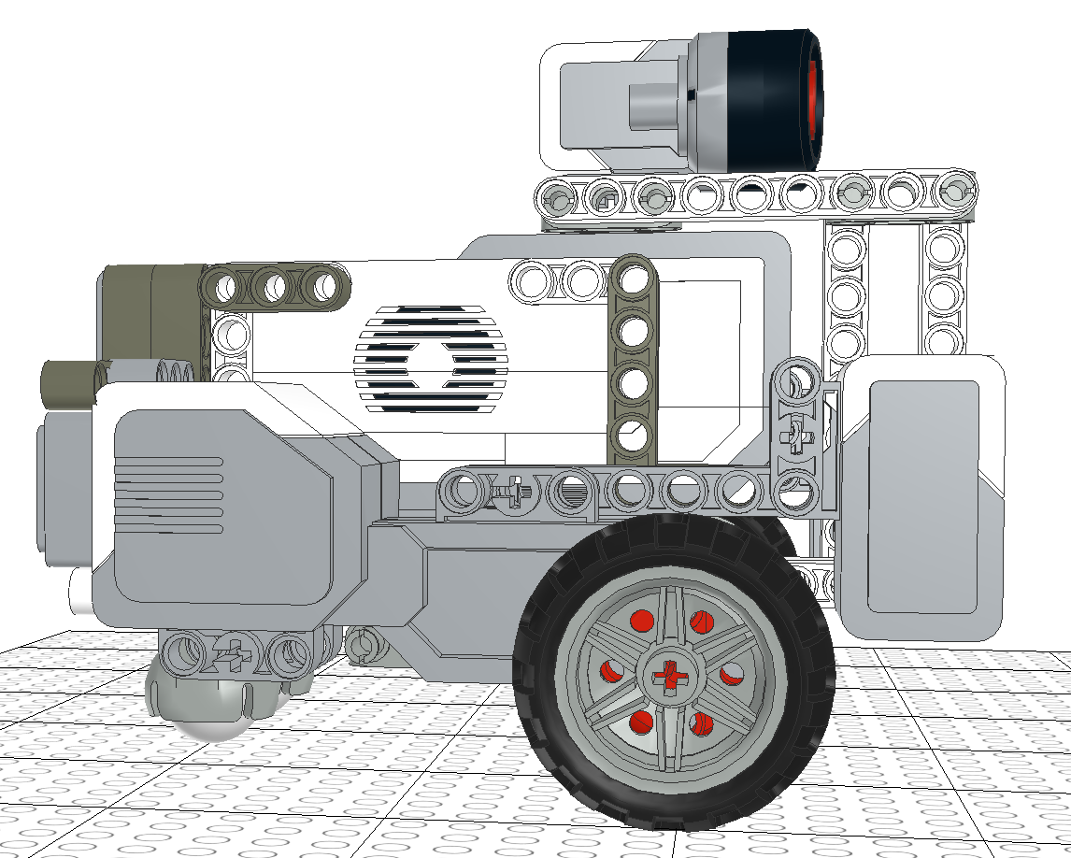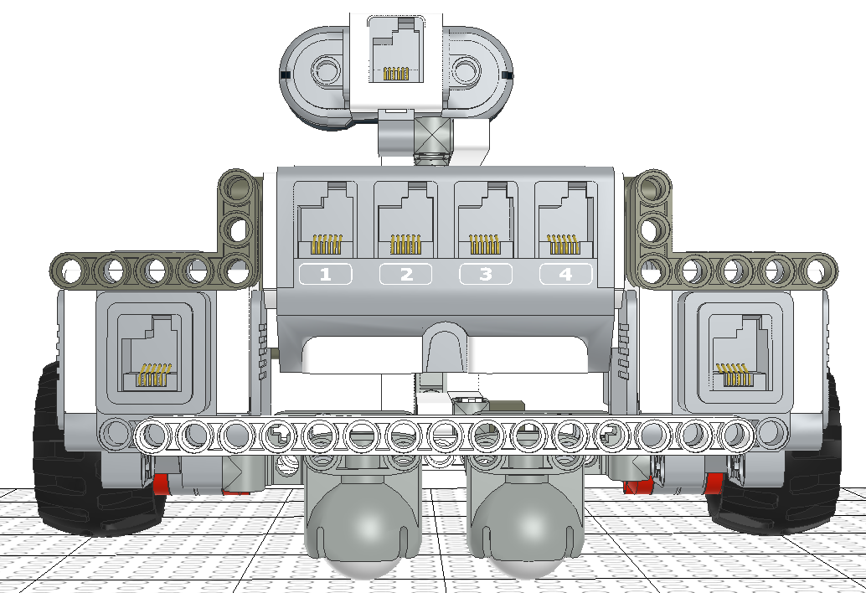

**Figure 15: Side view of Version 1.2 (V1.2) Figure 16: Back view of Version 1.2 (V1.2)**

Once again, to ensure that this Version (V1.2) is able to complete the tasks required, we tested it extensively. The testing summaries for Version 1.2 is shown in Table 2 below:

|  |  |  |  |  |
| --- | --- | --- | --- | --- |
| Hardware Design Version: | Name of Test: | Pass/Fail | Type of problem | Link to Testing Document: |
| V1.2 | Go Over Overpass | Fail | Hardware | Test 2 in [Go Over Overpass testing document](https://docs.google.com/document/d/1ntKasrLQ6Y_eLAAidyk6L0FvTIGCx-GSZtqNbJkSr4E/edit) |
| Ultrasonic Localization | Pass | N/A | Test 1 in [Ultrasonic Localization testing document](https://docs.google.com/document/d/1i5zXX2RkZB1bQ5AKaqs2tCCyuTMWAq7WKUjmvhXXKrA/edit) |
| Light Localization | Pass | N/A | Test 1 in [Light Localization testing document](https://docs.google.com/document/d/1hbvZ0sSDDTCPsYO7X7Va-bQugIbLqwHuVHMDkOEr22A/edit) |

Table 2: Testing of V1.2

### **Version 1.3 (V1.3)**

However, after the testing of Version 1.2 of the robot, we can see from table 2 that the Go Over Overpass test still failed. Looking into Test 2 in the Go Over Overpass testing document, although the robot successfully navigated up the bridge (effectively fixing the problem with version 1.1), it was still unable to move down the bridge successfully. This is because after the adjustments were made for version 1.2, this led to our hardware components once again being more concentrated at the front-end of the robot, causing our robot’s center of gravity to be faced forward when moving down the bridge, before plunging forward and rolling down the slope. Hence, in order to solve this issue, we decided to move the ultrasonic sensor support to the back of the robot, so that the weight at the backend of the robot would be increased, shifting the center of gravity more so to the center of the robot.

With that being said, since Version 1.2 passed both the Ultrasonic Localization and Light Localization test, thus, to maintain the success of these functionalities, the positions of the ultrasonic and light sensors remain unchanged for our new and improved design (V1.3). The latest version (V1.3) of our design is shown in Figure 17, Figure 18 and Figure 19 below.

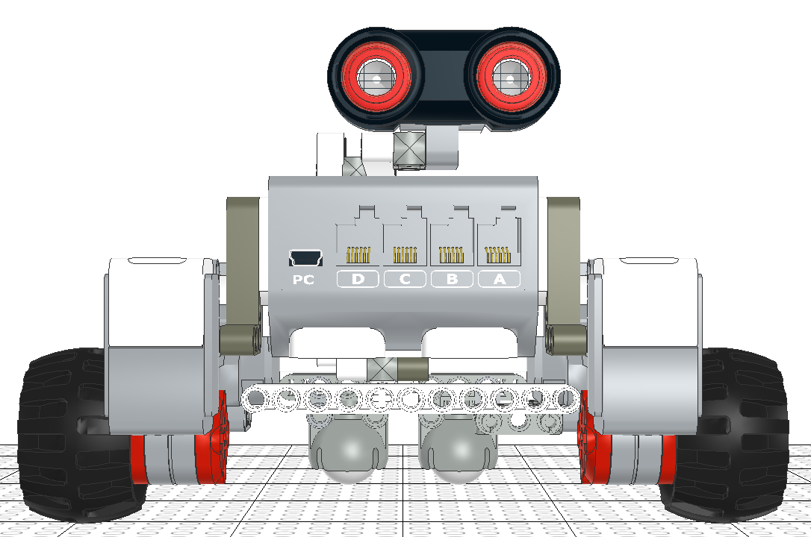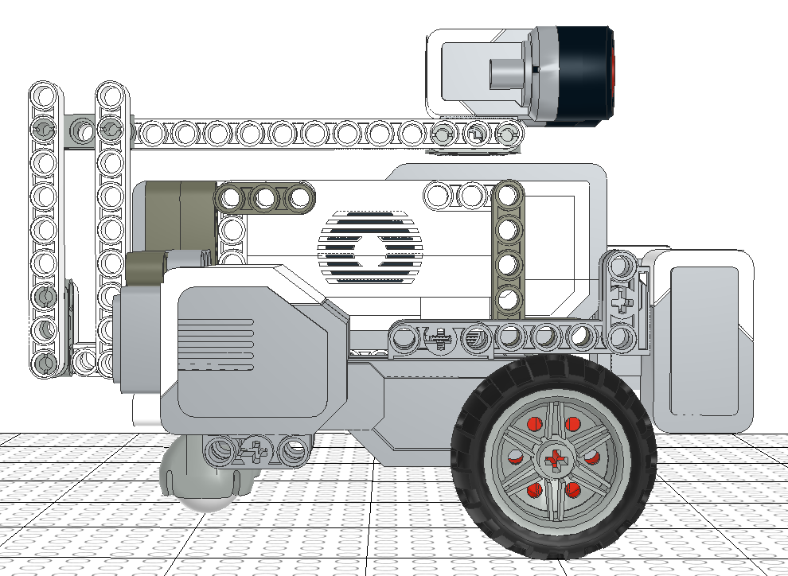

**Figure 17: Front view of Version 1.3 (V1.3) Figure 18: Side view of Version 1.3 (V1.3)**

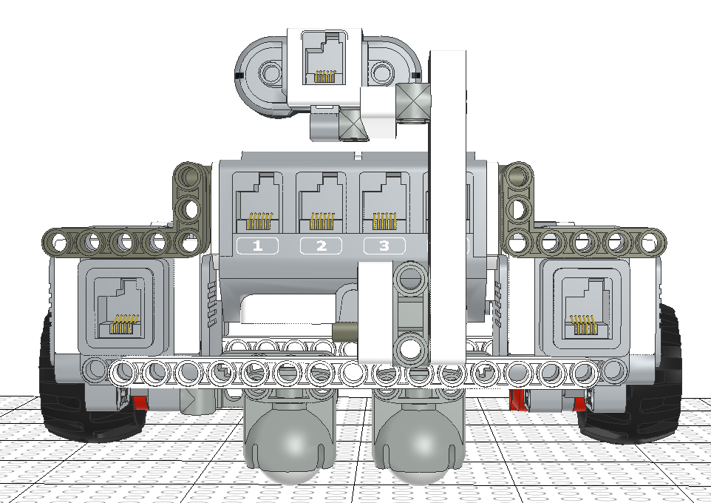

**Figure 19: Back view of Version 1.3 (V1.3)**

The tests done on Hardware Design V1.3 is shown in Table 3 below:

|  |  |  |  |  |
| --- | --- | --- | --- | --- |
| Hardware Design Version: | Name of Test: | Pass/Fail | Type of problem | Link to Testing Document: |
| V1.3 | Go Over Overpass | 3 Trials Failed  2 Trial Passed | Hardware | Test 3 in [Go Over Overpass testing document](https://docs.google.com/document/d/1ntKasrLQ6Y_eLAAidyk6L0FvTIGCx-GSZtqNbJkSr4E/edit) |

Table 3: Testing of V1.3

### **Version 1.4 (V1.4)**

From Table 3, we once again tested the robot to see if the persisting issue of going over the overpass was fixed. Unfortunately, our design Version 1.3 (V1.3) was only able to pass 2 of 5 trials when attempting to cross the overpass, failing 3 times. However, for the 2 times that it passed, as noted in Test 3 of the [Go Over Overpass testing document](https://docs.google.com/document/d/1ntKasrLQ6Y_eLAAidyk6L0FvTIGCx-GSZtqNbJkSr4E/edit), the robot was observed to be very unstable when going down the slope, leading us to believe that the problem with V1.3 was a matter of stability. Therefore, in order to increase stability of the robot, the placement of the ultrasonic sensor support was reconfigured so that it was symmetrical to the robot, allowing for the weight of the robot to be more balanced. This new and adjusted model of our robot is Version 1.4 (V1.4) The physical model of Hardware Design V1.4 is shown below in Figures 20, 21, 22 below.

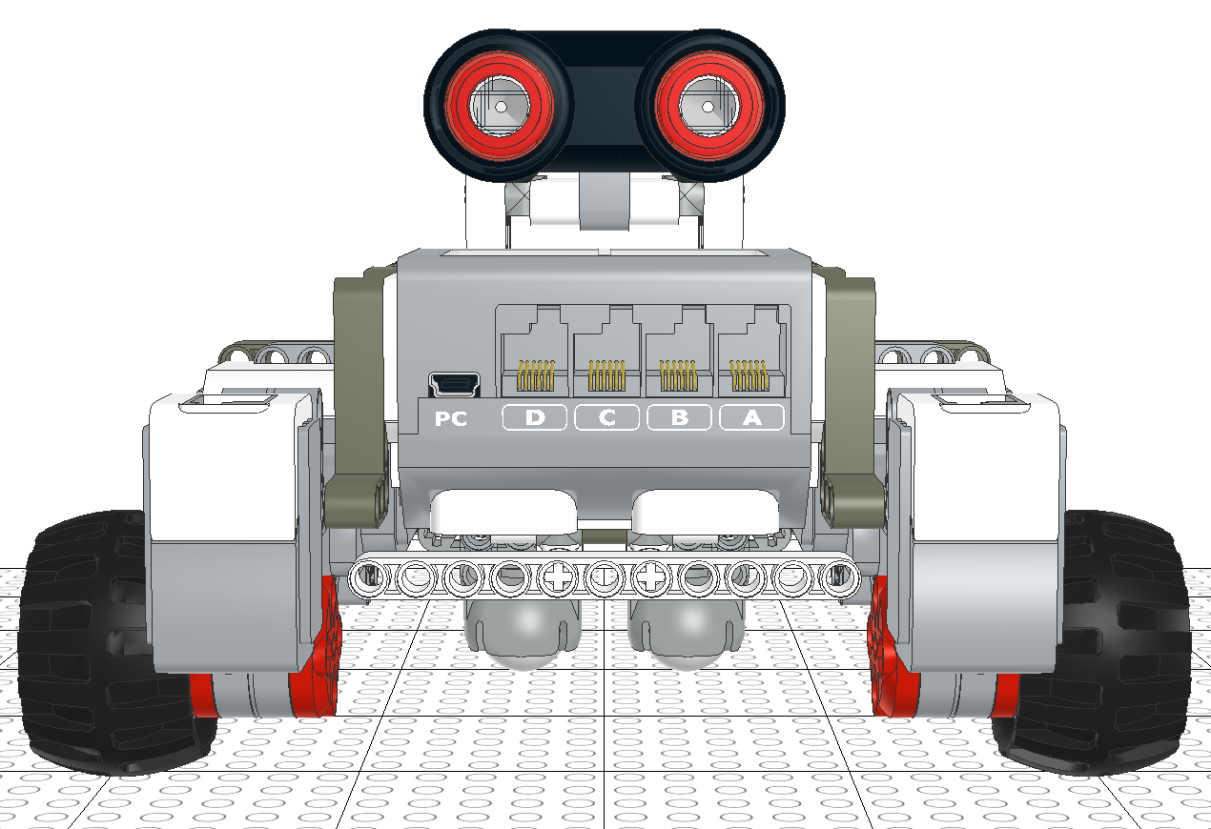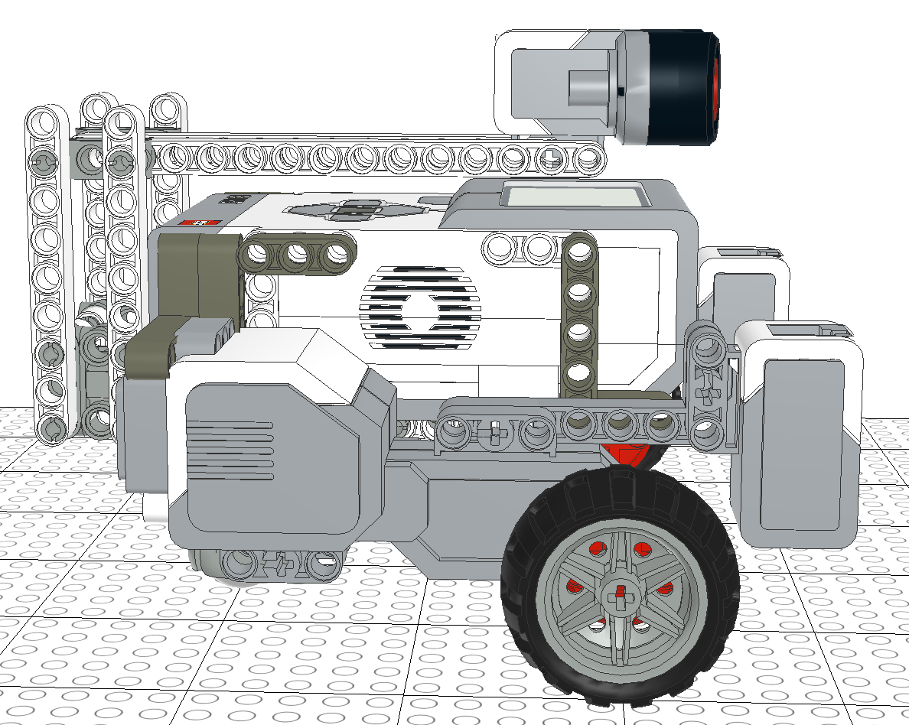

**Figure 20: Front view of Version 1.4 (V1.4) Figure 21: Side view of Version 1.4 (V.4)**

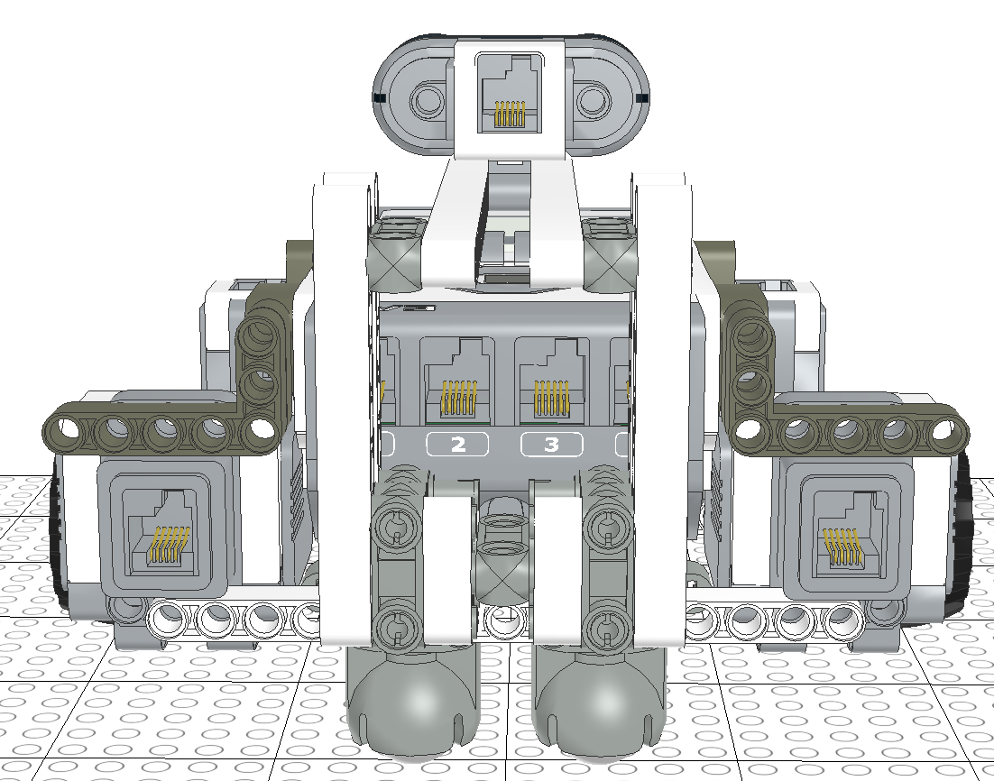

**Figure 22: Back view of Version 1.4 (V1.4)**

The tests conducted on Hardware Design V1.4 is shown in the Table below:

|  |  |  |  |  |
| --- | --- | --- | --- | --- |
| Hardware Design Version: | Name of Test: | Pass/Fail | Type of problem | Link to Testing Document: |
| V1.4 | Go Over Overpass | Fail | Hardware | Test 4 in [Go Over Overpass testing document](https://docs.google.com/document/d/1ntKasrLQ6Y_eLAAidyk6L0FvTIGCx-GSZtqNbJkSr4E/edit) |

Table 4: Testing of V1.4

From Table 4, we can see that even after the changes made for Version 1.4 (V1.4), our design still failed the Go over overpass test. As seen in the test description of Test 4 of the Go over overpass testing document, not only was the stability issue not solved, our robot was too heavy to even navigate up the slope. Here, since this is a step back from Version 1.3 (V1.3), where V1.3 at least passed the Go Over Overpass test 2 times, we scrapped V1.4 and decided to find an alternate solution for our V1.3.

As such, since our hardware changes didn’t work, instead of approaching the stability issue from a hardware perspective, we decided to look at it from a software perspective. Shifting this over to the software team, they were able to find a solution to the stability issue by changing the parameters in the software implementation. This is explained in more detail in Section 7.1 - Version 1.4 of the [software design document](https://docs.google.com/document/d/19JaY5629aUu4Y4rjoQJ-jWyeQLqNSAcr/edit).

After the changes applied by the software design team, we tested our hardware design version 1.3 extensively. A summary of the tests conducted are shown in the table below.

|  |  |  |  |  |
| --- | --- | --- | --- | --- |
| Hardware Design Version: | Name of Test: | Pass/Fail | Type of problem | Link to Testing Document: |
| V1.3 | Go Over Overpass | Pass | N/A | Test 6 in [Go Over Overpass testing document](https://docs.google.com/document/d/1ntKasrLQ6Y_eLAAidyk6L0FvTIGCx-GSZtqNbJkSr4E/edit) |
| Return Back From Island | Pass | N/A | Test 2 in [Return Back testing document](https://docs.google.com/document/d/1FBtxROm1xwYeoYW5ALSHYr2V5moykrTor_v7g1cWxvg/edit) |
| Return Back From Island | Fail | Hardware | Test 3 in [Return Back testing document](https://docs.google.com/document/d/1FBtxROm1xwYeoYW5ALSHYr2V5moykrTor_v7g1cWxvg/edit) |
| Navigation | Pass | N/A | Test 1 in [Navigation testing document](https://docs.google.com/document/d/1OZXy8YqvSSrNrOsIWyWCu_IZifpUpeZtN-kmQz0zkjM/edit) |
| Go Under Overpass | Pass | N/A | Test 2&3 in [Go Under Overpass testing document](https://docs.google.com/document/d/1ApCq7hXxCLwaWe6oN9_eNqux0iLiI2UIqdQqZ_-585A/edit) |
| Odometer | Pass | N/A | Test 1&2 in [Odometer testing document](https://docs.google.com/document/d/117R2YlyTxwgqMCLdjMXxlnttLYPf0wbNThisRhWShSU/edit#heading=h.aqymsd81oryi) |

Table 5: Testing of V1.3 after software adjustments

### **Version 1.5 (V1.5)**

As seen from Table 5, we can see that after the adjustments made on the software side of this project, our Hardware Design Version 1.3 (V1.3) has successfully passed the Go Over Overpass test that V1.4 failed. In addition to this, V1.3 also passed the Navigation test, Go Under Overpass test and Odometer test. The only test that failed due to a hardware problem was the return back from island test. As outlined in the test description (Test 3 in Return back testing document), the reason for the failure was because in one of the many trials for that test, the tail of the ultrasonic sensor support at the back of the robot collided with the bridge, altering the direction of the robot in motion. Therefore, in order to avoid this, we decided to reduce the length of the ultrasonic sensor support, decreasing the size of it whilst keeping all the other components unchanged. This adjusted and improved design is Version 1.5 (V1.5), and its physical model can be seen in Figures 23, 24 and 25.

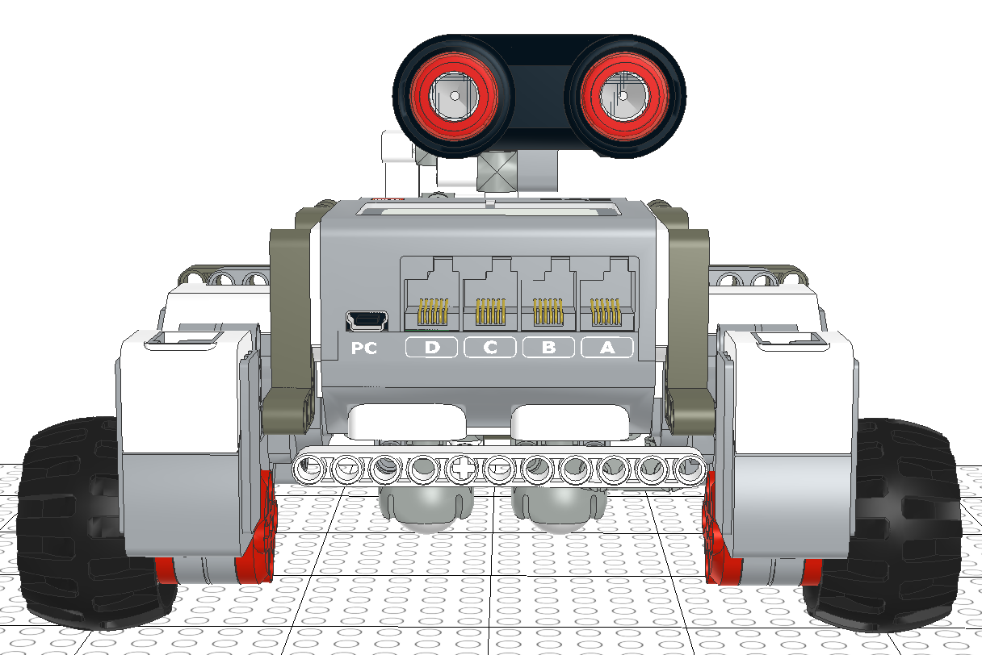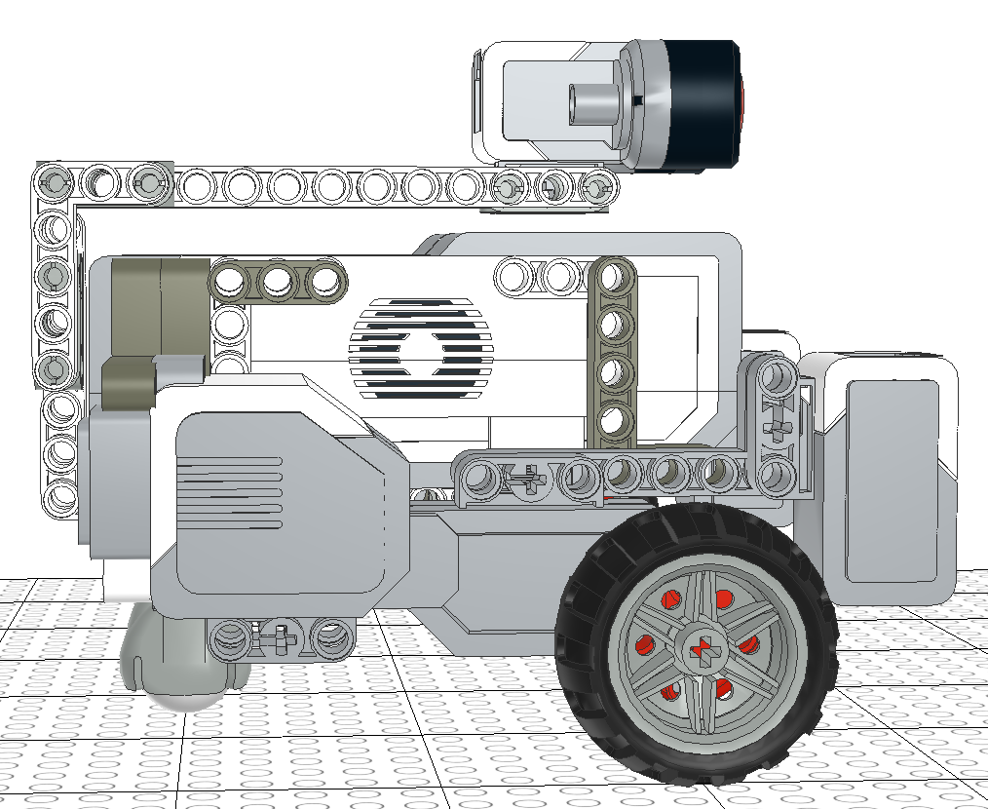

**Figure 23: Front view of Version 1.5 (V1.5) Figure 24: Side view of Version 1.5 (V1.5)**

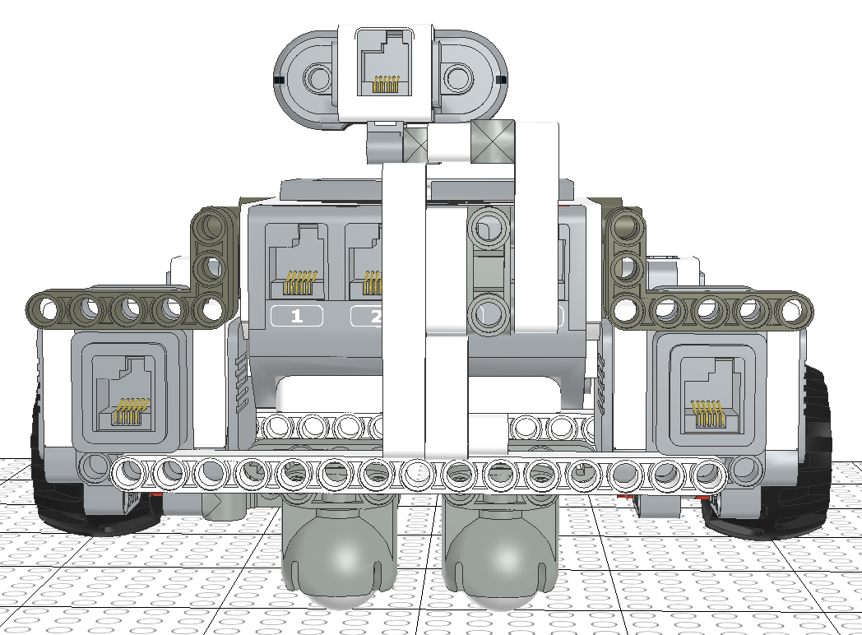

**Figure 25: Back view of Version 1.5 (V1.5)**

The tests we ran on Hardware Design Version 1.5 can be summarised in Table 6 below:

|  |  |  |  |  |
| --- | --- | --- | --- | --- |
| Hardware Design Version: | Name of Test: | Pass/Fail | Type of problem | Link to Testing Document: |
| V1.5 | Go Over Overpass | Pass | N/A | Test 7 in [Go Over Overpass testing document](https://docs.google.com/document/d/1ntKasrLQ6Y_eLAAidyk6L0FvTIGCx-GSZtqNbJkSr4E/edit) |
| Return Back From Island | Pass | N/A | Test 4 in [Return Back testing document](https://docs.google.com/document/d/1FBtxROm1xwYeoYW5ALSHYr2V5moykrTor_v7g1cWxvg/edit) |
| Pre-Beta Demo test | Pass | N/A | Test 3 in [Pre-Beta Demo testing document](https://docs.google.com/document/d/1ON8UKJ_YReQTtxSYWl7Dh810YPmuWamyQt2pKF4q3a8/edit#heading=h.f778ahkyw85) |
| Beta Demo Test (Unofficial) | Pass | N/A | Test 3 in [Beta Demo testing document](https://docs.google.com/document/d/1_cBBKc-2ap1MLJntkO9TeHmJczp5TSSxhR-7uMhMAg0/edit) |

Table 6: Testing of V1.5

# **3.0 FINAL DESIGN**

After a series of tests, failures and improvements, our final design is the one as shown in Figure 23, 24 and 25 above. The ultrasonic sensor support, which stretches up and above the robot to the middle, is placed at the rear-end of the robot and is attached to the ultrasonic sensor at the top-middle of the robot. However, the length and size of the tail end of the support was reduced. Both the two ball casters and two color sensors remain at the back and front of the robot respectively, except that the position of both these components are slightly raised as compared to our initial design A. Everything else including the wheels were untouched, being located at the exact same position as in design A.

This final design is stable, compact, and able to navigate through the playing field as well as avoid obstacles consistently.

(Note that our final design may change throughout the course of our project, and improvements/adjustments will be added to section 2.5 accordingly)

# **4.0 GLOSSARY OF TERMS**